18 April – DB first Assignment
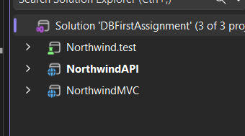
Create 3 projects: API for backend, MVC for frontend and test for unit testing

In API Project use these 3 commands :
dotnet add package Microsoft.EntityFrameworkCore.SqlServer --version 8.0.10
dotnet add package Microsoft.EntityFrameworkCore.Tools --version 8.0.10
dotnet add package Microsoft.EntityFrameworkCore.Design --version 8.0.10
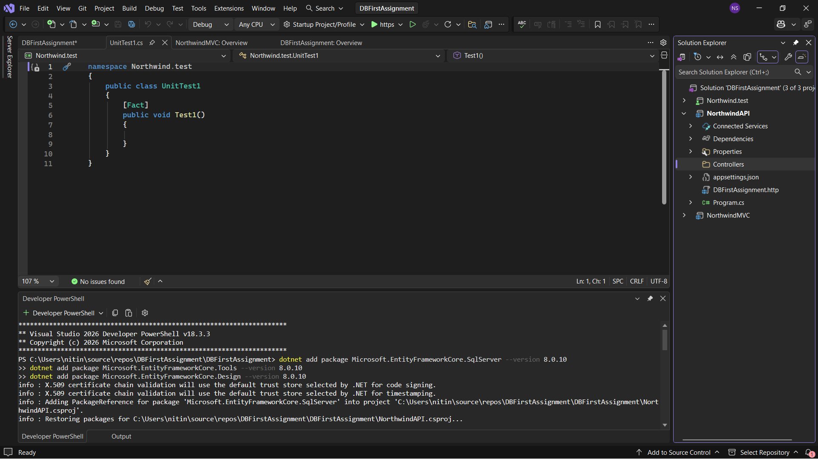

Now add this command for DB first approach

Now on models folder, products and category are added
Now find Northwind context file in models and find onmodelcreating () and override it for fluent API which is another requirement.

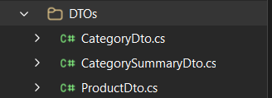
Create 3 DTOs.

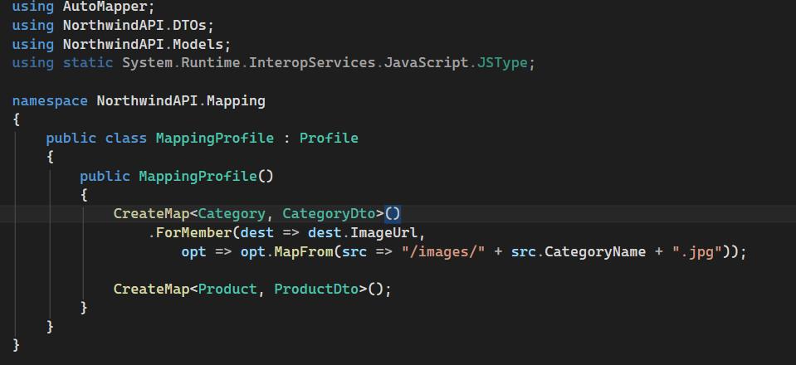
Create a mapping profile for DTOs.
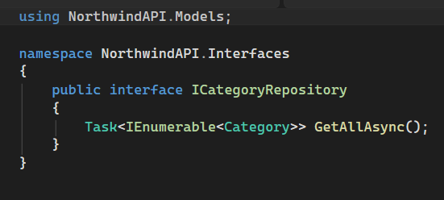
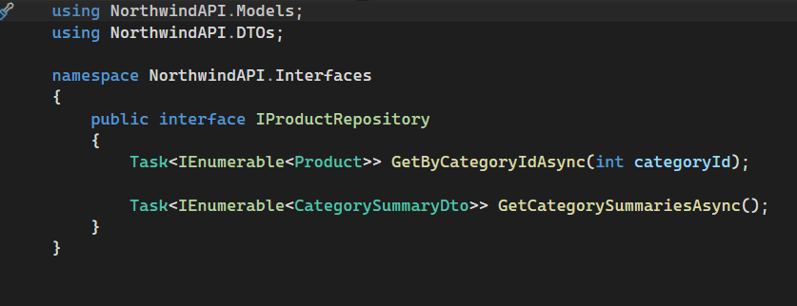
Create Interfaces for repositories and write the respective code.
Now create controller and write the controller code.
after you are done with code of all repositories and controller, now we will add Connection string in appsettings.json and will register everything in program.cs.
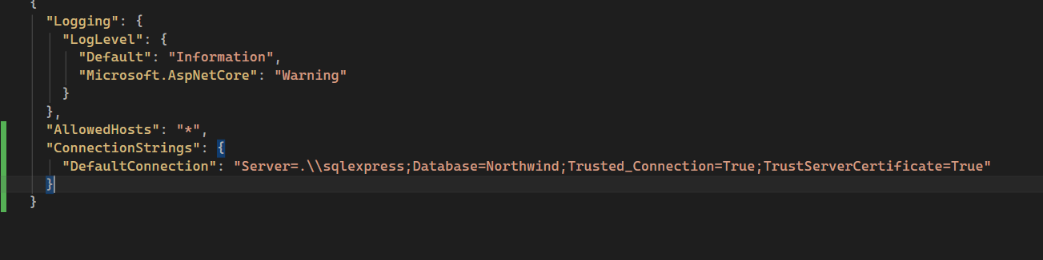

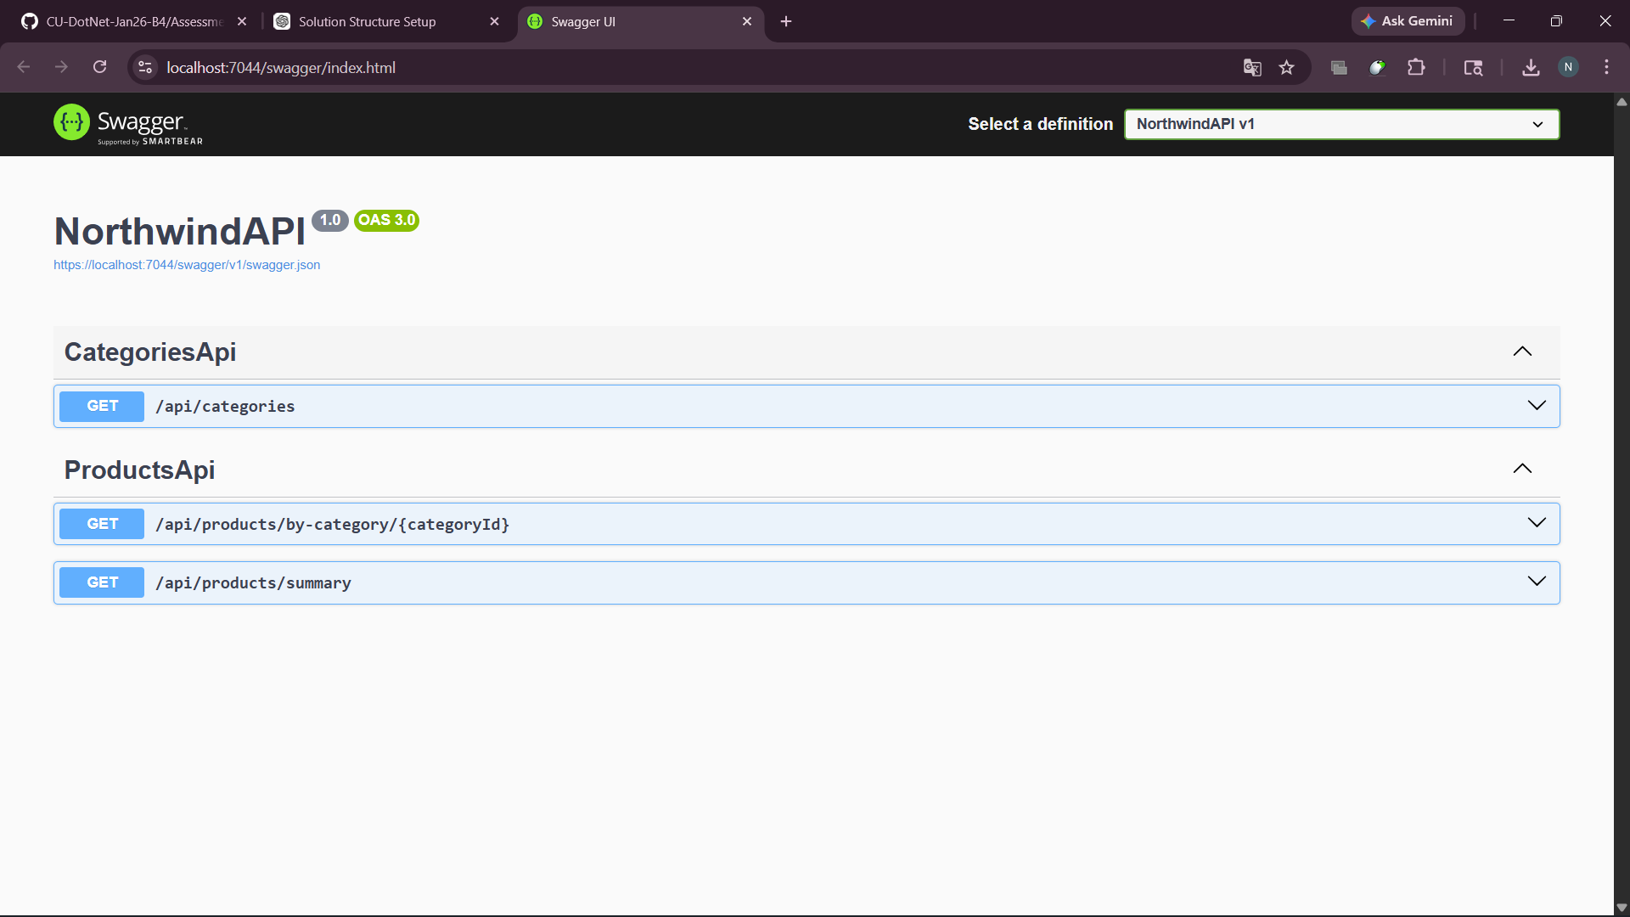
Run the API and it should look like this.
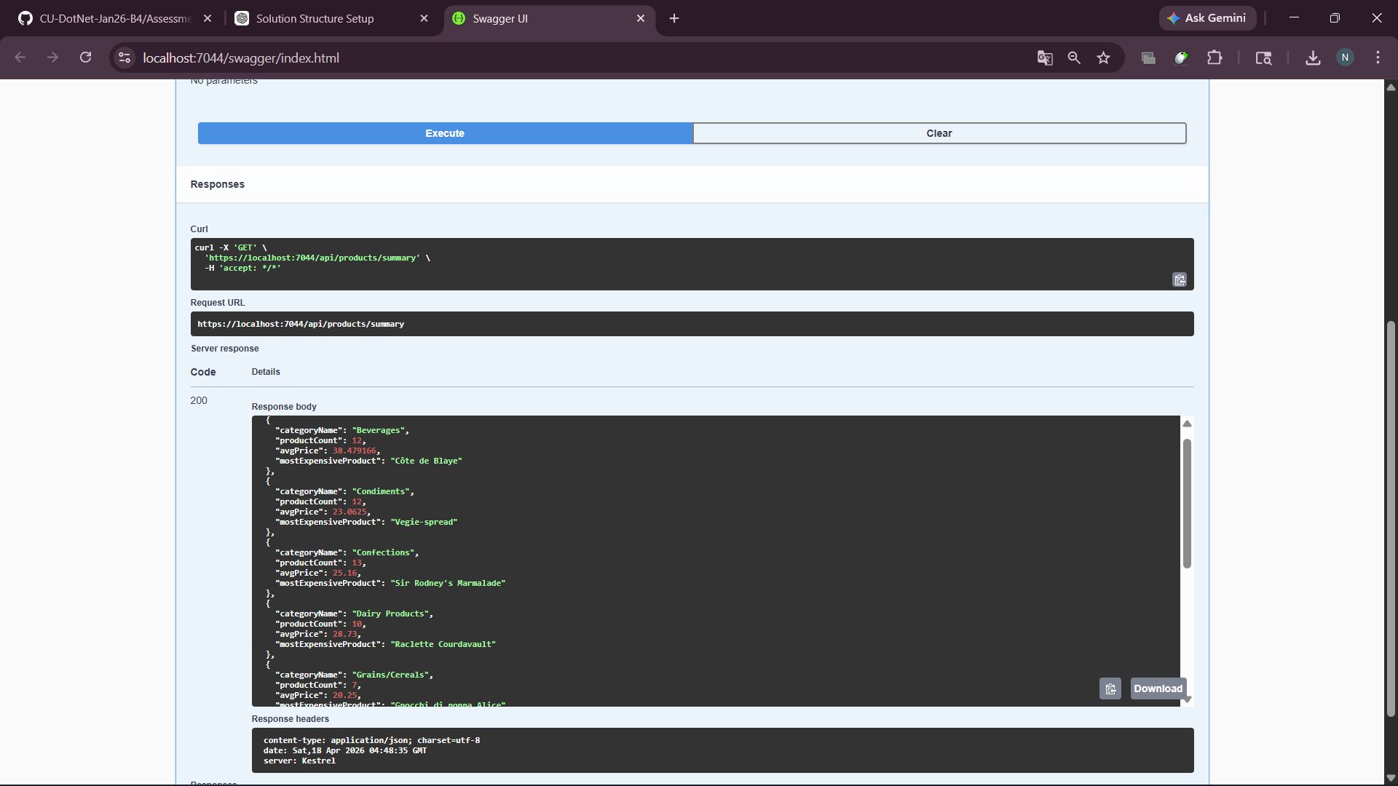
Check if all endpoints are working or not.
NOW THE API(BACKEND) PART IS DONE!
We will start with MVC Part

Add 3 DTOs in Models folder of MVC.
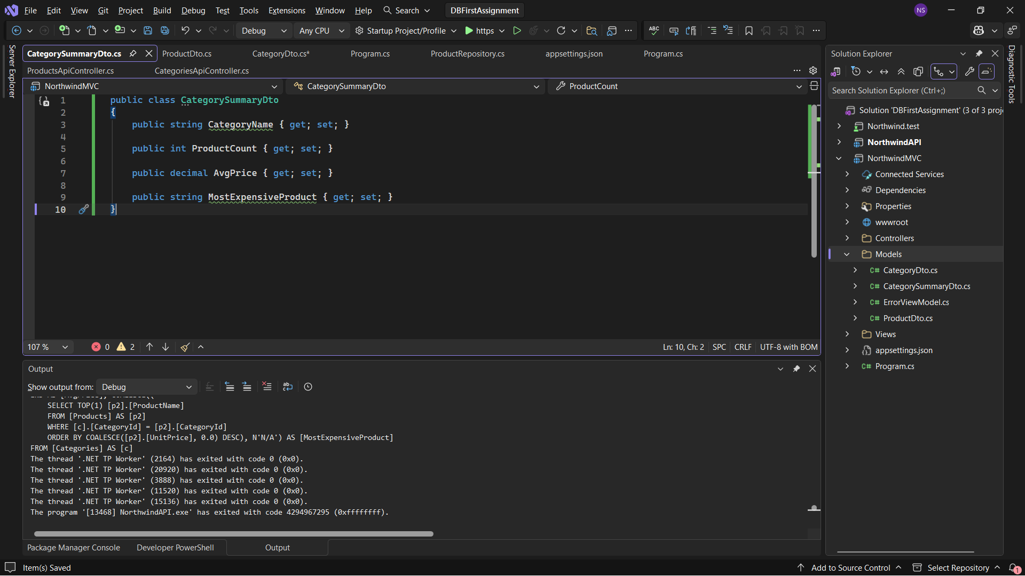
Now add controller with views and you MVC structure will look like this.
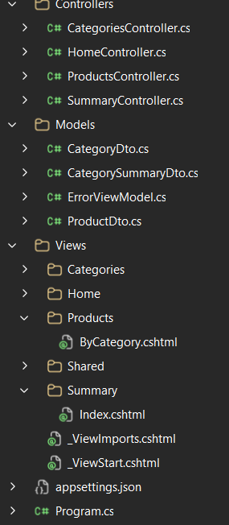
Now try to run MVC app with API using Multiple startup projects.
Also edit layout.cshtml for better navigation and finally your mvc should look like this.
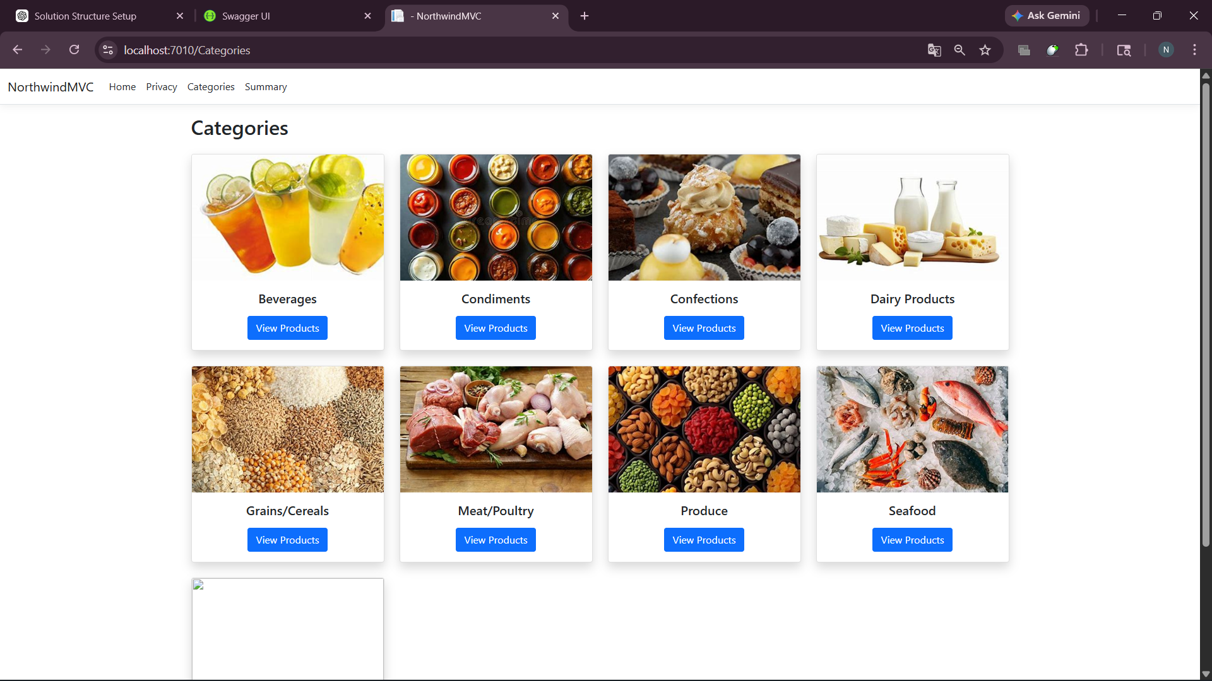

For the unit testing paste this code to check whether the values are retrieved fine or not.
using Xunit;
using NorthwindMVC.Models;

namespace Northwind.test
{
public class ProductTests
{
[Fact]
public void InventoryValue_Should_Return_Correct_Value()
{
// Arrange
var product = new ProductDto
{
ProductName = "Test Product",
UnitPrice = 10,
UnitsInStock = 5
};

// Act
var result = product.InventoryValue;

// Assert
Assert.Equal(50, result);
}
}
}

Now all 3 projects are done .
the assignment has now been completed.

